Homework 9
- Op amp applications
- You have designed a simple op-amp circuit for a particular application. During your initial testing, you find that the op amp is very hot to touch. Assuming that the circuit has been correctly breadboarded, what is the most likely problem an what can you do to correct it? (5)

- How could you increase the output current of an op amp? Show your work and diagrams. (5)

- Distribution amplifier
I want to have a gain of 50 and the output signal is evenly distributed into three loads (each load has a gain of 50 of the input).
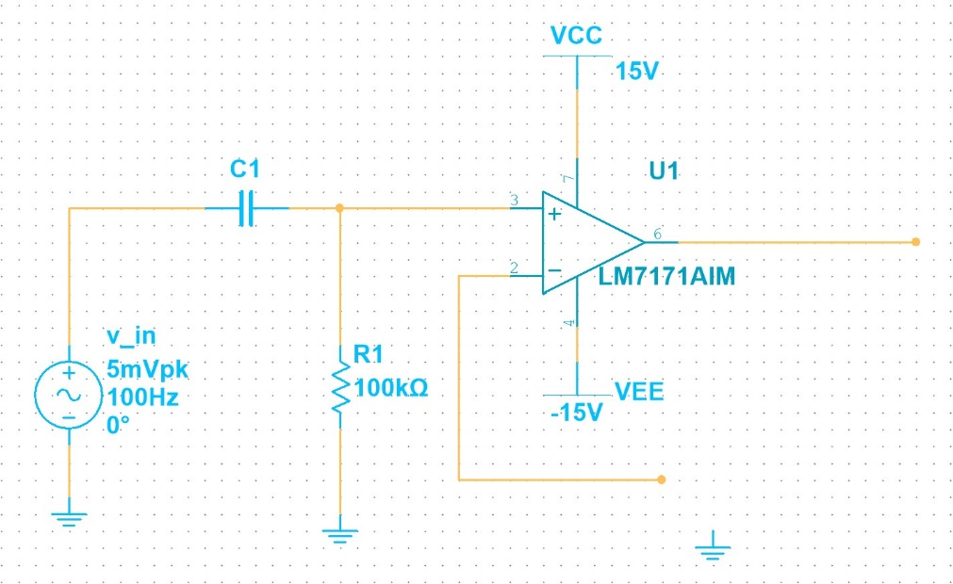
- Finish designing my circuit below. Include all the components values and labels. (6)

- What are the output voltages? (6)

- What do the $C_{1}$ and $R_{1}$ do? Find a capacitor that will allow signals above 800 Hz to pass. (8)

- Current boosters
I built this following circuit:
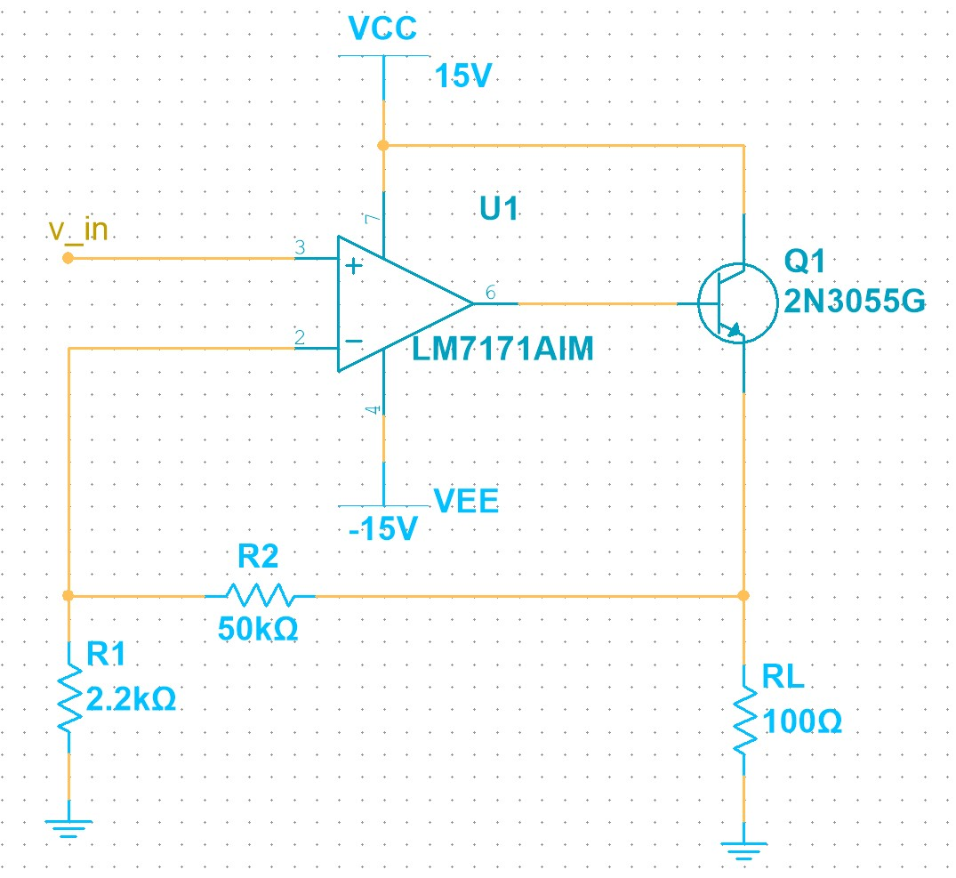
- Describe how this circuit works? What’s the voltage gain? (6)

- May I send a DC input voltage? What’s the output voltage in this case? (4)

- May I send in an AC voltage? What’s the output now? What does the output waveform look like? (6)

- If $β_{DC}=70$, what’s the short-circuit output current? (4)

- Active filters
- Design an active filter allowing signals below 12kHz with a voltage gain in the passband of 5. Show your work. Insert your design below with Multisim. (10)

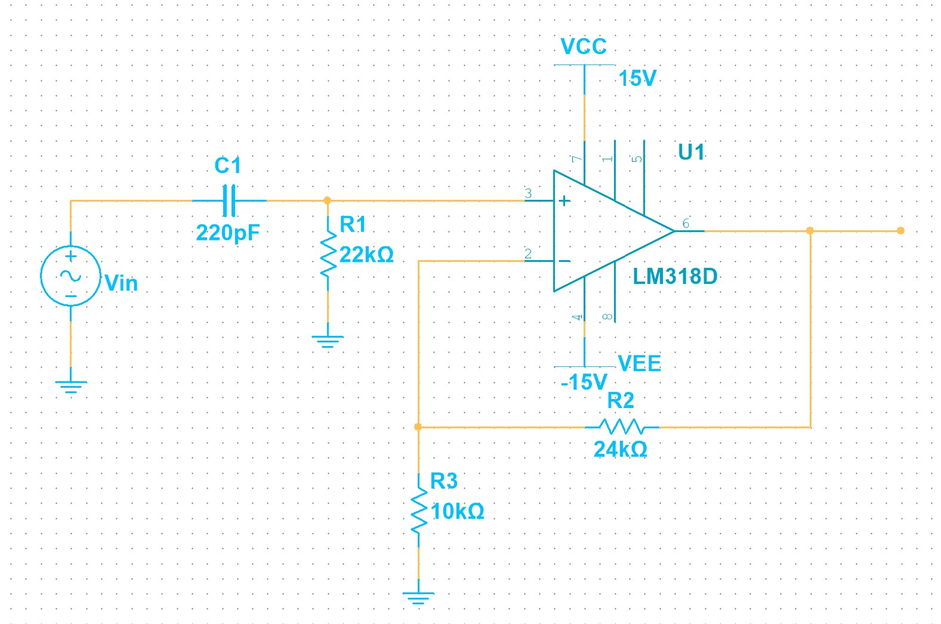
- Analyze the following circuit:

  - How does it work? (6)

  - What’s the cutoff frequency? (2)

  - What’s the voltage gain in the pass band? (2)

